Task 13
Created custom Nginx
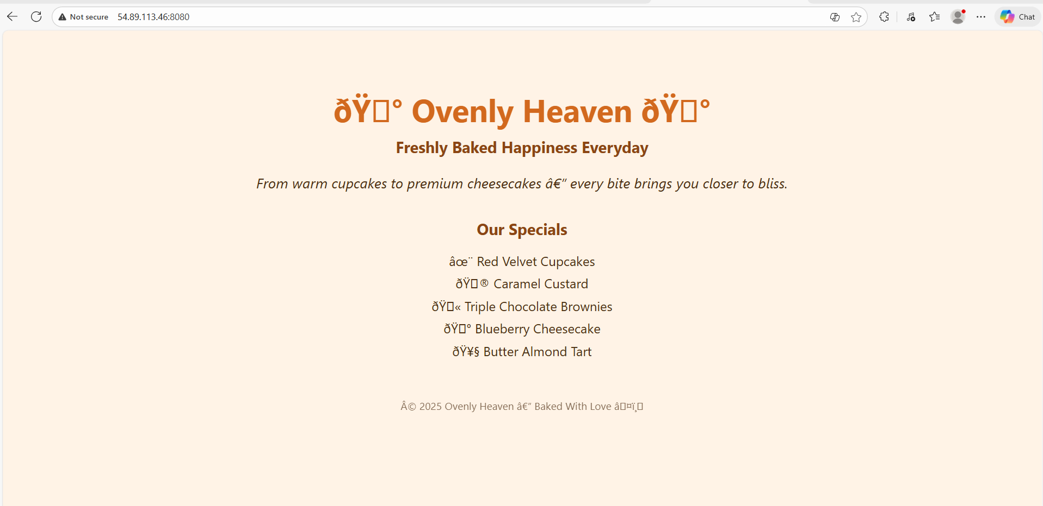
Build a final custom image
[root@ip-172-31-46-155 my-nginx]# docker images | grep ovenly
ovenly-nginx v1 b891308d00af 13 minutes ago 52.8MB
[root@ip-172-31-46-155 my-nginx]#
Image pushed to dockerhub
